**Preliminary report: The CADENAS Industry Forum 2017 revolves entirely around Industry 4.0 BIM and the optimisation of design processes**

Trends, innovations, best practice lectures and networking

**Germany, Augsburg, 31st January 2017.** Industry 4.0, or the digitalization of producing industries, is an important issue worldwide. The more individual components need to communicate with each other in the production process, the more intelligent digital data must be. Thus, a requirement for Industry 4.0 in mechanical engineering is that components have a digital twin. Hence, this year's international convention of CADENAS GmbH has also put emphasis on Industry 4.0. Moreover, engineers and component manufacturers can find out all about the topics of strategic parts management, electronic product catalogs and BIM from best practice lectures on trends and innovations.

**Process optimisation in design as a competitive edge**In numerous lectures, top-class speakers from renowned companies will convey to industry visitors how costs in engineering can be reduced sustainably with the strategic parts management PARTsolutions. In addition, the planned features of the new PARTsolutions version 11 from CADENAS will be presented.

**Best Practice PARTsolutions**

Michael Eder will talk about parts reduction and parts reuse at **Haas Food Equipment GmbH**. He will also explain how the geometric similarity search GEOsearch of the strategic parts management PARTsolutions supports the company.

Thomas Hecky of **BHS Corrugated Maschinen- und Anlagenbau GmbH** will report on the experiences of the optimisation of search time in design through intelligent finding and the synchronisation of the classification of SAP in PARTsolutions.

Peter Carrol of **IHS Markit** and Jürgen Thome of **CADENAS GmbH** will be reporting on the partnership of the two companies and will show the advantages for companies when using the strategic parts management in the aerospace industry.

Marco Kobylka will lecture on the introduction of repeated parts management and GEOsearch at **Wolf Verpackungsmaschinen GmbH** and explain the new working method and its resulting advantages for employees and customers.

Alen Blechinger, CEO of **CADENAS Solutions GmbH** in Wolfsburg, will outline the innovations of the geometric similarity search GEOsearch. Among other things, he will talk about innovations such as the classification of individual parts, the search for add-on components and partials as well as the new duplicate reports.

**Parker Hannifin Corporation** will be represented by Matthew Krupa, who will talk about parts management with PARTsolutions in corporate groups.

Highly anticipated as every year, the Head of Software Development at **CADENAS GmbH**, Frank Epple, will hold a speech. He will give engineers and purchasers an exclusive preview of the planned features of the new PARTsolutions Version 11.

During the best practice talks of the Industry-Forum, component manufacturers will learn how to fully exploit and further optimize the marketing potential of their products with electronic CAD product catalogs.

**Best Practice eCATALOGsolutions**

Simone Brinkmann-Tewes of **WAGO Kontakttechnik GmbH & Co. KG** tells about seamless process chains from planning to implementation with the digital twin.

**IMI Precision Engineering** explains how they plan to become a world-class online provider with an interactive product configurator from CADENAS, which is at the same time tied to the the eShop and the existing CRM solution. Ciaran Crowley will add the progress report.

The requirements necessary to obtain photorealistic product pictures from digital product models with eCATALOGsolutions and Maxwell Render will be explained by Anatol Kligermann of **Balluff GmbH**.

Stèphane Lucas of **LUCAS FRANCE** will report on the first step for Industry 4.0 with an electronic product catalog from CADENAS and an interactive product configurator.

**CADENAS** GmbH will be represented by Stefan Waldner. He will reveal the new functions and extensions of the 3D CAD models download portal PARTcommunity version 7.0 which engineers can look forward to.

**Taking advantage of potential in the areas of architecture and BIM with intelligent multi CAD data**

For manufacturers who wish to market their products also in the field of architecture, the topic of BIM will be present again this year at the Industry-Forum. Arnim Spengler, spokesman for **bimNRW Clusters**, will report on the step-by-step plan of the Federal Ministry for Transport and Digital Infrastructure (BMVI) and its contents in cooperation with CADENAS.Jürgen Heimbach, CEO of **CADENAS** will be talking about the demands coming upon the manufacturers of architecture components and how the software company provides optimal solutions with multi CAD data for AEC & CIM components.

**Application-oriented workshops with experts**

In addition to the numerous lectures, the 18th CADENAS Industry-Forum will offer structured guidance in application-oriented workshops for using CADENAS software solutions in daily working life.

In the area of electronic product catalogs, the participants will learn how component manufacturers are moving towards Industry 4.0 with an electronic product catalog. With eCATALOGsolutions, you enrich the engineering data of your products with intelligent information to thus create a twin. Together with the Mechatronics Concept Designer (MCD), the commissioning of technical systems can be virtually tested beforehand, for example, and detail co-ordination of the control system digitally carried out. This greatly shortens the lead time to production start for your customers.

In the area of strategic parts management, professional visitors can attend the workshop for PURCHINEERING. Are certain components always the most cost-efficient? The engineer often lacks knowledge from the purchasing department. PURCHINEERING builds on greater cooperation between purchasing and development, e.g. to find alternative suppliers or to create make or buy reports to achieve enormous competitive advantages.

The international convention Industry-Forum will include a trade exhibition as well as an evening event on 15 March 2017.

For **registrations up to 31/01/2017**, CADENAS offers an **early bird rate of 299 Euros** instead of the regular 399 Euros (price per person, plus VAT):  [www.industry-forum.biz/anmeldung](http://www.industry-forum.biz/anmeldung)

Further information about the 18th CADENAS Industry-Forum 2017 and registration can be found at: [www.industry-forum.biz](http://www.industry-forum.biz/)

**Press Images:**

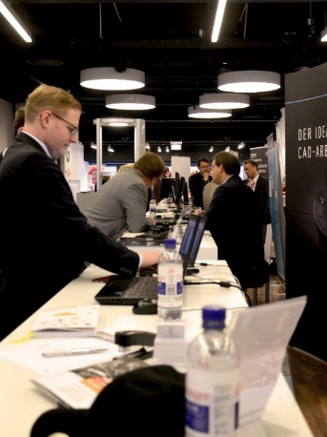

**Caption 1:** The international convention Industry Forum will include a trade exhibition as well as an evening event on 15 March 2017.

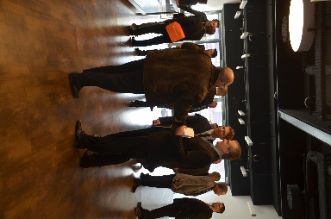

**Caption 2:** Specialists make valuable contacts with companies in their industry.

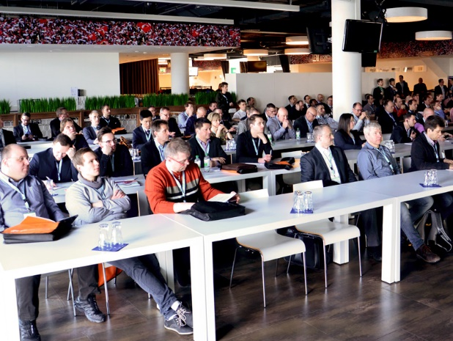

**Caption 3:** In numerous lectures, top-class speakers from renowned companies will convey to industry visitors how costs in engineering can be reduced sustainably with the strategic parts management PARTsolutions.

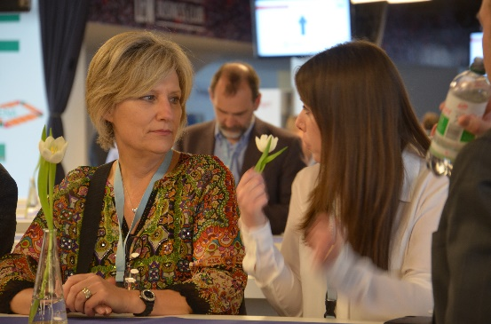

**Caption 4:** During the best practice talks of the Industry-Forum, component manufacturers will learn how to fully exploit and further optimize the marketing potential of their products with electronic CAD product catalogs.

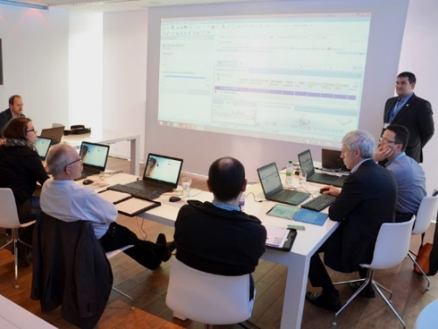

**Caption 5:** In addition to the numerous lectures, the 18th CADENAS Industry Forum will offer structured guidance in application-oriented workshops for using CADENAS software solutions in daily working life.

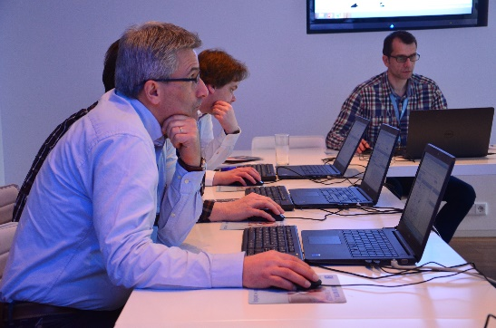

**Caption 6:** Numerous participants take part in the workshop in small groups - so they can be looked after very well and all questions answered.

This press release and accompanying images are available for download from our website: [www.cadenas.de/press/press-releases](http://www.cadenas.de/press/press-releases)

**About CADENAS**

CADENAS is a leading software developer in the areas of Strategic Parts Management and parts reduction (PARTsolutions), as well as Electronic Product Catalogs (eCATALOGsolutions). With its customized software solutions, the company acts as a link between the component manufacturers with their products and the purchasers.

With its 300 employees at 17 international subsidiaries, the name CADENAS (Hispanic: process chains) has been standing for success, creativity, support and process optimization since 1992.

For further information, please visit: www.cadenas.de/en